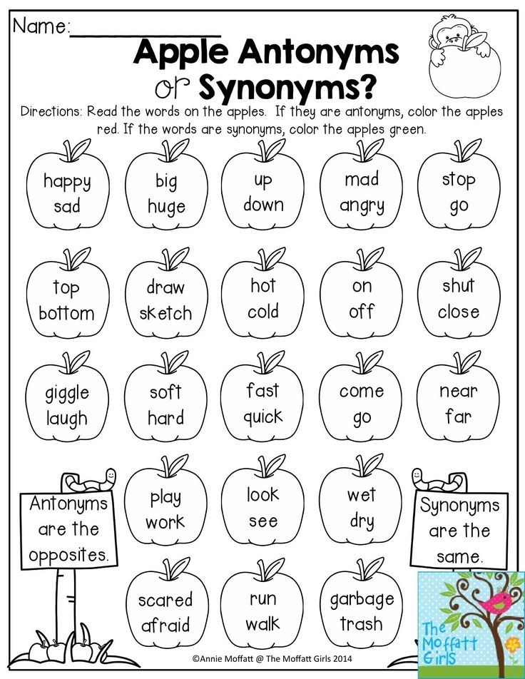
LG: To recognise synonyms and antonyms

