Group 3: Poetry Recitation Feedback

 | 1 | 2 | 3 | Score Earned
Voice | The student’s voice was unclear or shaky for most of the recitation. | The student’s voice was a little unclear at times. | The student spoke in a clear voice.
Volume | The student could not be heard across the room. | The student could be heard across the room most of the time. | He/she could be heard across the room the entire time.
Expression | The student did not use any expression in the recitation.  All of the words sounded the same. | The student used some expression and emphasised a few words in the recitation. | The student used expression during the whole recitation. It was fun to listen to the poem.
Pacing | The student spoke too fast or too slow during the recitation. | The student spoke at a good pace for most of the poem.  There may have been one or two pauses, but the poem still flowed well. | The student spoke at a good pace the entire poem.  The student spoke faster or slower in some parts to create emphasis.
 |  |  | Total Score:
Student Performing the Recitation: ________________________________________ Date: ___________

Student Providing Feedback: ________________________________________

Title of the Poem Recited: ________________________________________

Overall, I think the strongest part of your recitation was when you _________________________________________

_______________________________________________________________________________________________.

I think this was the best part because ________________________________________________________________

_______________________________________________________________________________________________.

(Think specifically about the positive impact it had on their overall poem.)

One thing that I think you can do to make your recitation even stronger is ___________________________________

_______________________________________________________________________________________________.

Student Performing the Recitation: ________________________________________ Date: ___________

Student Providing Feedback: ________________________________________

Title of the Poem Recited: ________________________________________

Group 2: Poetry Recitation Feedback
Focus Area | 1 | 2 | 3 | Score
Volume | -Hard to hear (too quiet)  -Way too loud (yelling) | -Parts of the poem were hard to hear. | -I could hear the poem easily.
Pace | -Way too fast  -Way too slow | -A little choppy  -The poem did not flow  -There were long pauses | -Good pace  - Not too fast, not too slow  -The poem flowed well
Expression | -Voice was the same the whole time  -No expression  -It was not interesting for the audience | -A little expression used  -A few words were emphasised | -A lot of expression was used  -Several words were emphasised  -It was engaging for the audience
 |  |  | Total Score

In my opinion, the best part of your poem was _________________________________________________________

_______________________________________________________________________________________________.

I thought this part was the best because you __________________________________________________________

_______________________________________________________________________________________________.

I think if you work on _____________________________________________________________________________

_______________________________________________________________ it will make your poem even stronger!

Student Performing the Recitation: ________________________________________ Date: ___________

Student Providing Feedback: ________________________________________

Title of the Poem Recited: ________________________________________

Group 1: Poetry Recitation Feedback
 | 1 | 2 | 3 | Score
Volume  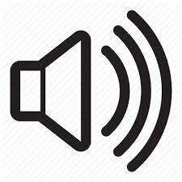 | - too quiet  - cannot hear the words at all | - whisper voice  - can just hear | - normal speaking voice  - can hear the words easily.
Expression  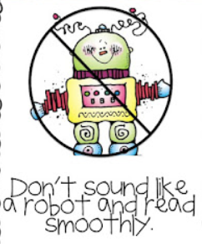 | - no expression  - robot like | - some expression  - some of the words sound different | - lots of expression  - interesting to listen to
Pace  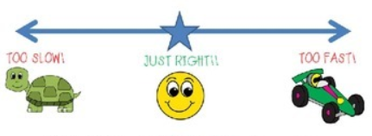 | - too slow  - too quick | - choppy  - some part are too fast or too slow | - a just right speed  - I can understand  - It sounded like talking speed
 |  |  | Total Score

My favourite part of your poem was when you _________________________________________________________

_______________________________________________________________________________________________.

