[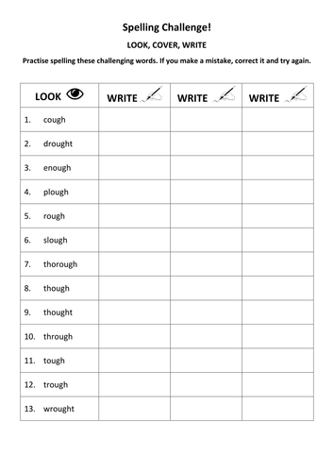](https://www.google.com.au/url?sa=i&source=images&cd=&cad=rja&uact=8&ved=2ahUKEwjj1urYza_bAhUJVrwKHVIxDhcQjRx6BAgBEAU&url=https%3A%2F%2Fwww.tes.com%2Fteaching-resource%2Fks3-spelling-practice-look-cover-write-words-with-ough-11446711&psig=AOvVaw1a1gXmTzA762NdSr8Fy4Au&ust=1527844299129937)