[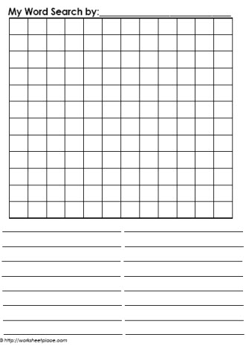](https://www.google.com.au/url?sa=i&source=images&cd=&cad=rja&uact=8&ved=2ahUKEwj9_LXC06zbAhWHiLwKHcnZDYoQjRx6BAgBEAU&url=https%3A%2F%2Fwww.worksheetplace.com%2Findex.php%3Ffunction%3DDisplaySheet%26sheet%3DBlank-wordsearch-1%26links%3D3%26id%3D%26link1%3D43%26link2%3D310%26link3%3D74&psig=AOvVaw1Yv4BZxdnJS0CyrIz1pS7v&ust=1527742772398431)