[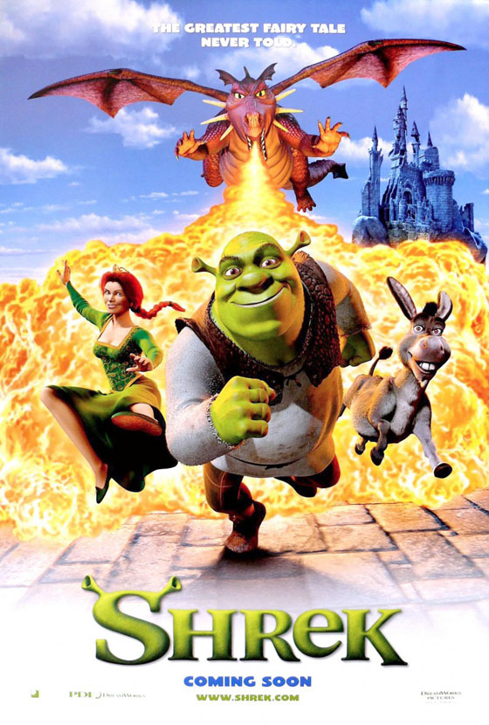](https://www.google.com.au/url?sa=i&rct=j&q=&esrc=s&source=images&cd=&cad=rja&uact=8&ved=2ahUKEwiB3q7X29HZAhWDxrwKHWGhAewQjRx6BAgAEAY&url=https://www.stunningmesh.com/2011/05/120-animated-cartoon-and-3d-movies-poster/&psig=AOvVaw3-AopMX3YVOGKS6-ZFfWQK&ust=1520220186730501)

**Who is the intended audience of this poster? How do you know?**

**What kind of movie is this? (comedy, adventure, fantasy). How do the images show this?**

**What do the characters, text and colours tell you about this movie?**

**LG**: To **analyse** visual images (movie posters).