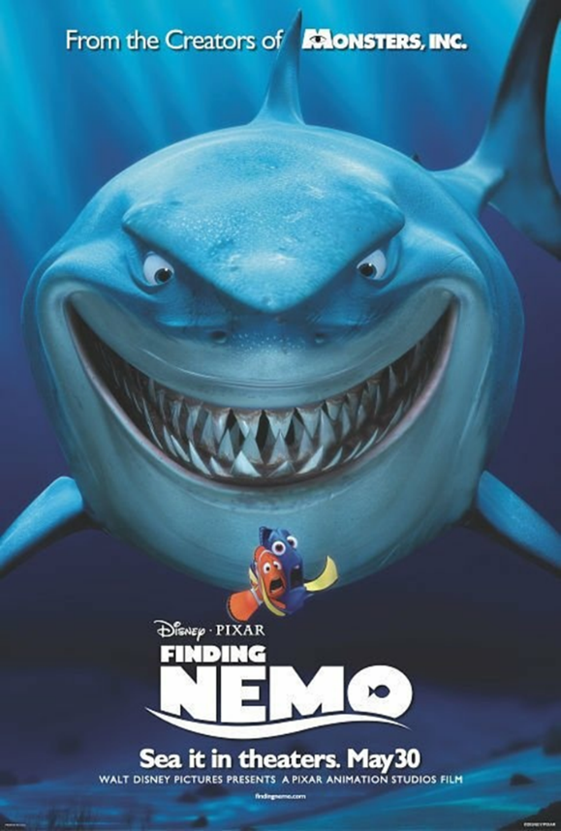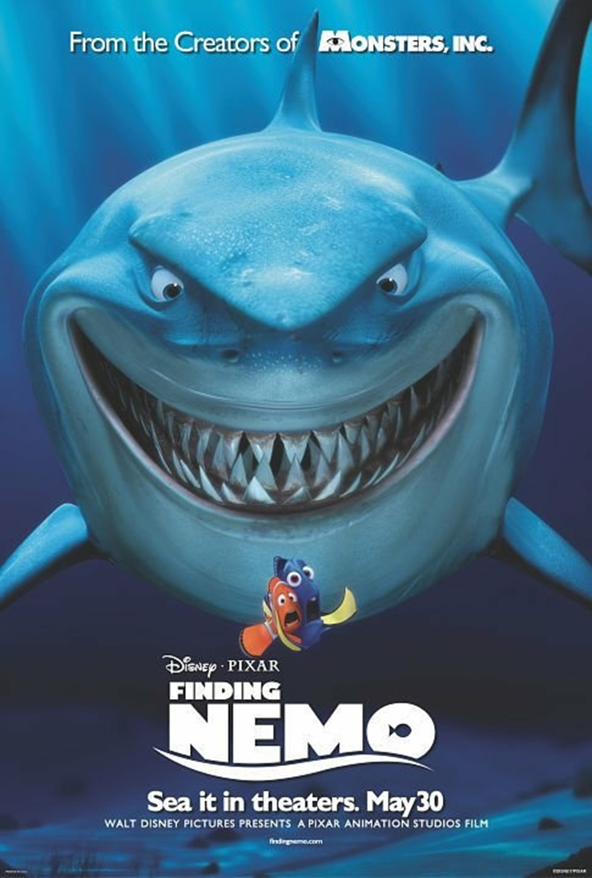

Cut out the small image of the movie poster and stick it in your book.

1. Who is the intended audience? How do you know?
2. What is the purpose of this poster?
3. Why are bright colours used in this poster?
4. Why are all of the character placed in the centre of the picture?
5. What do the character’s expressions tell you about the tone of this image?
6. Analyse the movie text at the bottom of the poster. Why do you think it is written like this?

**LG**: To **analyse** visual images (movie posters).